Stage 3 Physics: Sound and Waves Test 2014

Time: 60 minutes Total Marks = 60

Name: __________________

**Question 1 (4 marks)**

Explain the difference between a transverse and a longitudinal wave. Give an example of each in your explanation.

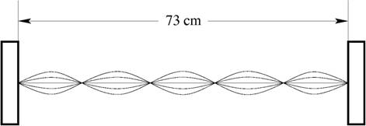**Question 2 (6 marks)**

A standing wave is set up on a stretched string of length 73 cm, as shown at right. The string vibrates at a frequency of 750 Hz when oscillating in the mode shown in the diagram. The amplitude of the antinodes is 10 mm.

(a) Which harmonic is shown in the diagram? (1 mark)

(b) What is the wavelength of the standing wave shown above? (1 mark)

(c) What is the speed of the waves in the string? (2 marks)

(d) What is the maximum displacement of the string from its rest position? (1 mark)

(e) How many times per second is the string completely straight? (1 mark)

**Question 3 (6 marks)**

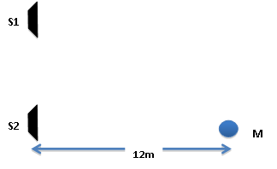Two loudspeakers (S1 and S2) are connected in phase to a frequency generator. A microphone M is placed 12 m directly in front of speaker S2. The frequency of the sound generated is varied so that the microphone detects a series of maximum and minimum intensity sounds. The lowest frequency at which a **minimum** intensity sound is detected at microphone M is 173 Hz.

(a) Explain how this minimum intensity sound is produced. (2 marks)

(b) Calculate the distance between the two speakers. (4 marks)

**Question 4 (4 marks)**

When an infantry brigade is crossing a bridge, the soldiers are instructed to break stride and to stop marching in order to prevent the possibility of the bridge collapsing. Explain how soldiers marching in time with one another could pose a danger to the structural integrity of the bridge. Use appropriate Physics terms in your explanation.

**Question 5 (5 marks)**

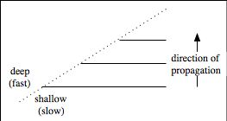The diagram at right shows water waves in a ripple tank moving towards a boundary between regions of shallow water and of deep water.

(a) State whether each of the following quantities increases, decreases or stays the same as the waves cross the boundary between the two regions. (3 marks)

Wave speed

Frequency

Wavelength

(b) Complete the diagram to show the behaviour of the waves as they cross the boundary between the two regions. (2 marks)

**Question 6 (5 marks)**

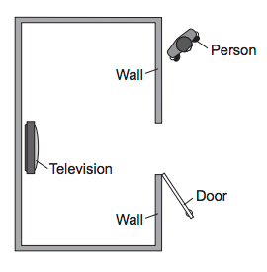A television is switched on in a room. A person outside the room can hear the sound when the door is open, but cannot see the television from where he is standing.

(a) On the diagram at right, sketch the path of the light waves passing through the doorway, and also show the behaviour of the sound waves as they pass through the doorway. Clearly label each type of wave. (2 marks)

(b) Explain why each type of wave behaves as it does. (3 marks)

**Question 7 (9 marks)**

A glass tube can have its effective length varied by moving a rubber stopper at the end of a metal rod as shown below. Initially, there is sawdust spread evenly inside the tube along its length. Jill blows a whistle at a constant frequency, while Jack steadily moves the rubber stopper until the sound suddenly gets very loud and the observation below is achieved.

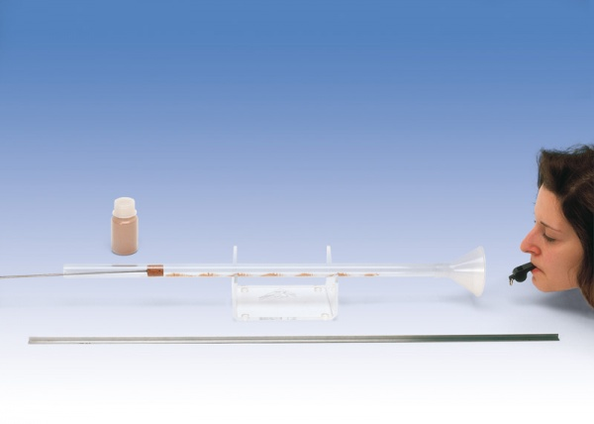

Clumps of sawdust

Rubber Stopper

Jack measures the distance between the clumps of sawdust and finds this to be 7.5 cm.

(a) Explain why the sawdust forms *clumps* as shown in the photograph. (2 marks)

(b) State why the sawdust clumps at the left end, next to the rubber stopper. (1 mark)

(c) The observations depicted in the photograph show that a standing wave is present in the glass tube. Explain how this standing wave has formed. Be sure to use appropriate Physics terms in your explanation. (3 marks)

(d) What is the frequency of the wave produced by Jill’s whistle? (3 marks)

**Question 8 (12 marks)**

The figure below shows the distribution of air particles in a pipe open at both ends that has a standing wave in it. At the instant shown in the figure, the particles are at their maximum displacement from their ‘rest’ positions. The pipe has a length of 0.80 m.



(a) Mark the position of any displacement nodes (N) and antinodes (A) in the pipe. (3 marks)

(b) Sketch a graph showing the displacement of the air particles as a function of distance along the pipe. You should assume that displacement to the “right” is positive. (3 marks)

(c) Which *harmonic* is present in the pipe? Explain. (2 marks)

(d) What are the frequency and the period of this standing wave? (3 marks)

(e) What is the fundamental frequency of this pipe? (1 mark)

**Question 9 (4 marks)**

The figure below represents four standing wave in a pipe of length L. The pipe is closed at one end. Use this figure to complete the table.

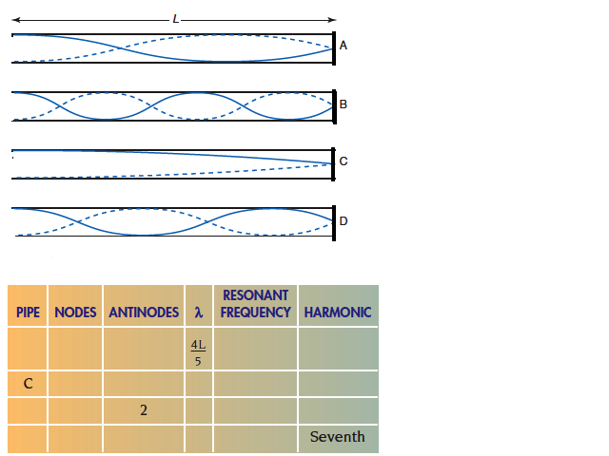

**Question 10 (5 marks)**

Dolphins and bats both use ultrasound waves with frequencies of up to 120 000 Hz as a form of sonar, emitting the waves and then listening for reflections, in order to navigate through their respective environments. Which animal would be better at distinguishing small objects and why?